PART B:

Microproject Report

1. **Summary**

Bank Management System is based on a concept of recording customer's account details. Here the user can perform all the tasks like creating an account, deposit amount, withdraw amount, check balance, view all account holders detail, close an account and modify an account. There's no login system for this project

1. **Course action addressed**

a. Develop C++ programs to solve problems using Procedure Oriented Approach.

b. Develop C++ programs using classes and objects.

c. Implement Inheritance in C++ program.

d. Use Polymorphism in C++ program.

e. Develop C++ programs to perform file operations.

1. **Actual methodology**
2. **Algorithm:**

**step 1 :** Create a class for BankAccount which would have the attributes like accountNumber, accountHolderName, accountBalance

**step 2 :** Create functions for opening a bank account, withtaking money, depositing money, displaying bank account details

**step 3 :** Create a menu for the user to select the desired operation for managing their bank account

**step 4 :** Create another class for Bank which would have the attributes like branchName, branchAddress, branchManager

**step 5 :** Create functions for creating a new bank branch, displaying the bank branch details, adding new customers

**step 6 :** Create a main() function in the program to call the functions of both the classes

**step 7 :** Create a loop to allow the user to select the desired operation and perform the desired operations on the bank account

**step 8 :** Exit the program after the user has completed all the operations.

1. **Flowchart:**



**c. Source code:**

#include<iostream>

#include<fstream>

#include<conio.h>

#include<stdlib.h>

#include<string.h>

using namespace std;

class bank

{

int accno;

char name[50];

long int deposit;

char type;

public:

void create_account(); //function to get data from user

void show_account() const; //function to show data on screen

void modify(); //function to add new customer

void dep(long int); //function to accept amount and add to balance amount

void draw(long int); //function to accept amount and subtract from balance amount

void report() const; //function to show data in tabular format

int retacno() const; //function to return account number

long int retdeposit() const; //function to return balance amount

char rettype() const; //function to return account type

}; //class ends here

void bank::create_account()

{

cout<<"\nEnter The account No. :";

cin>>accno;

cout<<"\n\nEnter The Name of The account Holder : ";

cin.ignore();

cin.getline(name,50);

cout<<"\nEnter Type of The account (C/S) : ";

cin>>type;

type=toupper(type);

cout<<"\nEnter The Initial amount(>=500 for Saving and >=1000 for current ) : ";

cin>>deposit;

cout<<"\n\n\nAccount Created..";

}

void bank::show_account() const

{

cout<<"\nAccount No. : "<<accno;

cout<<"\nAccount Holder Name : ";

cout<<name;

cout<<"\nType of Account : "<<type;

cout<<"\nBalance amount : "<<deposit;

}

void bank::modify()

{

cout<<"\nAccount No. : "<<accno;

cout<<"\nModify Account Holder Name : ";

cin.ignore();

cin.getline(name,50);

cout<<"\nModify Type of Account : ";

cin>>type;

type=toupper(type);

cout<<"\nModify Balance amount : ";

cin>>deposit;

}

void bank::dep(long int x)

{

deposit+=x;

}

void bank::draw(long int x)

{

deposit-=x;

}

void bank::report() const

{

cout<<accno<<"\t\t"<<name<<"\t\t"<<type<<"\t\t"<<deposit<<"\n";

}

int bank::retacno() const

{

return accno;

}

long int bank::retdeposit() const

{

return deposit;

}

char bank::rettype() const

{

return type;

}

//***************************************************************

// function declaration

//****************************************************************

void write_account(); //function to write record in binary file

void display_sp(int); //function to display account details given by user

void modify_account(int); //function to modify record of file

void delete_account(int); //function to delete record of file

void display_all(); //function to display all account details

void deposit_withdraw(int, int); // function to desposit/withdraw amount for given account

void intro(); //introductory screen function

//***************************************************************

// THE MAIN FUNCTION OF PROGRAM

//****************************************************************

int main()

{

char ch;

int num;

intro();

do

{

system("cls");

cout<<"\n\n\n\tMAIN MENU";

cout<<"\n\n\t01. NEW ACCOUNT";

cout<<"\n\n\t02. DEPOSIT AMOUNT";

cout<<"\n\n\t03. WITHDRAW AMOUNT";

cout<<"\n\n\t04. BALANCE ENQUIRY";

cout<<"\n\n\t05. ALL ACCOUNT HOLDER LIST";

cout<<"\n\n\t06. CLOSE AN ACCOUNT";

cout<<"\n\n\t07. MODIFY AN ACCOUNT";

cout<<"\n\n\t08. EXIT";

cout<<"\n\n\tSelect Your Option (1-8): ";

cin>>ch;

system("cls");

switch(ch)

{

case '1':

write_account();

break;

case '2':

cout<<"\n\n\tEnter The account No. : "; cin>>num;

deposit_withdraw(num, 1);

break;

case '3':

cout<<"\n\n\tEnter The account No. : "; cin>>num;

deposit_withdraw(num, 2);

break;

case '4':

cout<<"\n\n\tEnter The account No. : "; cin>>num;

display_sp(num);

break;

case '5':

display_all();

break;

case '6':

cout<<"\n\n\tEnter The account No. : "; cin>>num;

delete_account(num);

break;

case '7':

cout<<"\n\n\tEnter The account No. : "; cin>>num;

modify_account(num);

break;

case '8':

cout<<"\n\n\tThanks for using bank managemnt system";

break;

default :cout<<"\a";

}

cin.ignore();

cin.get();

}while(ch!='8');

return 0;

}

//***************************************************************

// function to write in file

//****************************************************************

void write_account()

{

bank ac;

ofstream outFile;

outFile.open("account.dat",ios::binary|ios::app);

ac.create_account();

outFile.write(reinterpret_cast<char *> (&ac), sizeof(bank));

outFile.close();

}

//***************************************************************

// function to read specific record from file

//****************************************************************

void display_sp(int n)

{

bank ac;

bool flag=false;

ifstream inFile;

inFile.open("account.dat",ios::binary);

if(!inFile)

{

cout<<"File could not be open !! Press any Key...";

return;

}

cout<<"\nBALANCE DETAILS:\n";

while(inFile.read(reinterpret_cast<char *> (&ac), sizeof(bank)))

{

if(ac.retacno()==n)

{

ac.show_account();

flag=true;

}

}

inFile.close();

if(flag==false)

cout<<"\n\nAccount number does not exist";

}

//***************************************************************

// function to modify record of file

//****************************************************************

void modify_account(int n)

{

bool found=false;

bank ac;

fstream File;

File.open("account.dat",ios::binary|ios::in|ios::out);

if(!File)

{

cout<<"File could not be open !! Press any Key...";

return;

}

while(!File.eof() && found==false)

{

File.read(reinterpret_cast<char *> (&ac), sizeof(bank));

if(ac.retacno()==n)

{

ac.show_account();

cout<<"\n\nEnter The New Details of account"<<endl;

ac.modify();

int pos=(-1)*static_cast<int>(sizeof(bank));

File.seekp(pos,ios::cur);

File.write(reinterpret_cast<char *> (&ac), sizeof(bank));

cout<<"\n\n\t Record Updated";

found=true;

}

}

File.close();

if(found==false)

cout<<"\n\n Record Not Found ";

}

//***************************************************************

// function to delete record of file

//****************************************************************

void delete_account(int n)

{

bank ac;

ifstream inFile;

ofstream outFile;

inFile.open("account.dat",ios::binary);

if(!inFile)

{

cout<<"File could not be open !! Press any Key...";

return;

}

outFile.open("Temp.dat",ios::binary);

inFile.seekg(0,ios::beg);

while(inFile.read(reinterpret_cast<char *> (&ac), sizeof(bank)))

{

if(ac.retacno()!=n)

{

outFile.write(reinterpret_cast<char *> (&ac), sizeof(bank));

}

}

inFile.close();

outFile.close();

remove("account.dat");

rename("Temp.dat","account.dat");

cout<<"\n\n\tRecord Deleted ..";

}

//***************************************************************

// function to display all accounts deposit list

//****************************************************************

void display_all()

{

bank ac;

ifstream inFile;

inFile.open("account.dat",ios::binary);

if(!inFile)

{

cout<<"File could not be open !! Press any Key...";

return;

}

cout<<"\n\n\t\tACCOUNT HOLDER LIST\n\n";

cout<<"====================================================\n";

cout<<"A/c no. NAME Type Balance\n";

cout<<"====================================================\n";

while(inFile.read(reinterpret_cast<char *> (&ac), sizeof(bank)))

{

ac.report();

}

inFile.close();

}

//****************************************************************

// function to deposit and withdraw amounts

//****************************************************************

void deposit_withdraw(int n, int option)

{

int amt;

bool found=false;

bank ac;

fstream File;

File.open("account.dat", ios::binary|ios::in|ios::out);

if(!File)

{

cout<<"File could not be open !! Press any Key...";

return;

}

while(!File.eof() && found==false)

{

File.read(reinterpret_cast<char *> (&ac), sizeof(bank));

if(ac.retacno()==n)

{

ac.show_account();

if(option==1)

{

cout<<"\n\n\tTO DEPOSIT AMOUNT ";

cout<<"\n\nEnter The amount to be deposited : ";

cin>>amt;

ac.dep(amt);

}

if(option==2)

{

cout<<"\n\n\tTO WITHDRAW AMOUNT ";

cout<<"\n\nEnter The amount to withdraw : ";

cin>>amt;

int bal=ac.retdeposit()-amt;

if((bal<500 && ac.rettype()=='S') || (bal<1000 && ac.rettype()=='C'))

cout<<"Minimun Account balance of 1000 is required, Please enter a valid amount to withdraw";

else

ac.draw(amt);

}

int pos=(-1)*static_cast<int>(sizeof(ac));

File.seekp(pos,ios::cur);

File.write(reinterpret_cast<char *> (&ac), sizeof(bank));

cout<<"\n\n\t Record Updated";

found=true;

}

}

File.close();

if(found==false)

cout<<"\n\n Record Not Found ";

}

//***************************************************************

// INTRODUCTION FUNCTION

//****************************************************************

void intro()

{

cout<<"\n\n\n\t BANK";

cout<<"\n\n\tMANAGEMENT";

cout<<"\n\n\t SYSTEM";

cout<<"\n\n\n\n By Group Number : 4";

cout<<"\nPress Enter to continue....";

cin.get();

}

//***************************************************************

// END OF PROJECT

//***************************************************************

1. **Microproject output**

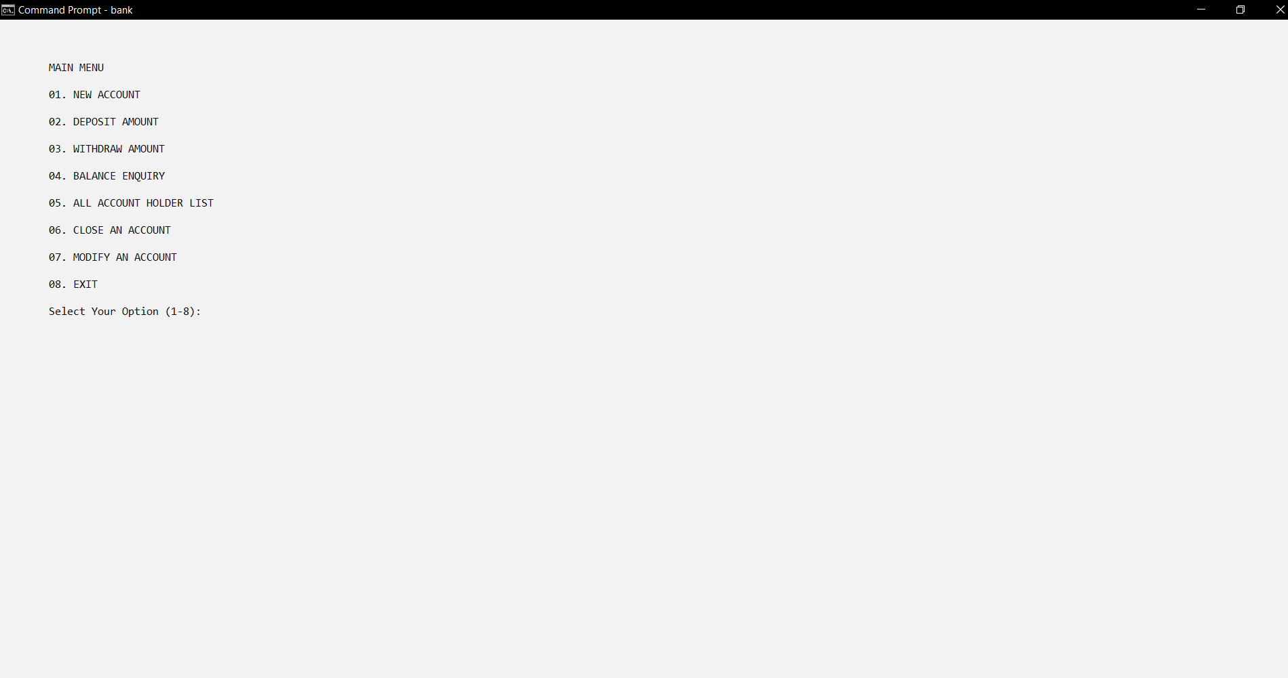

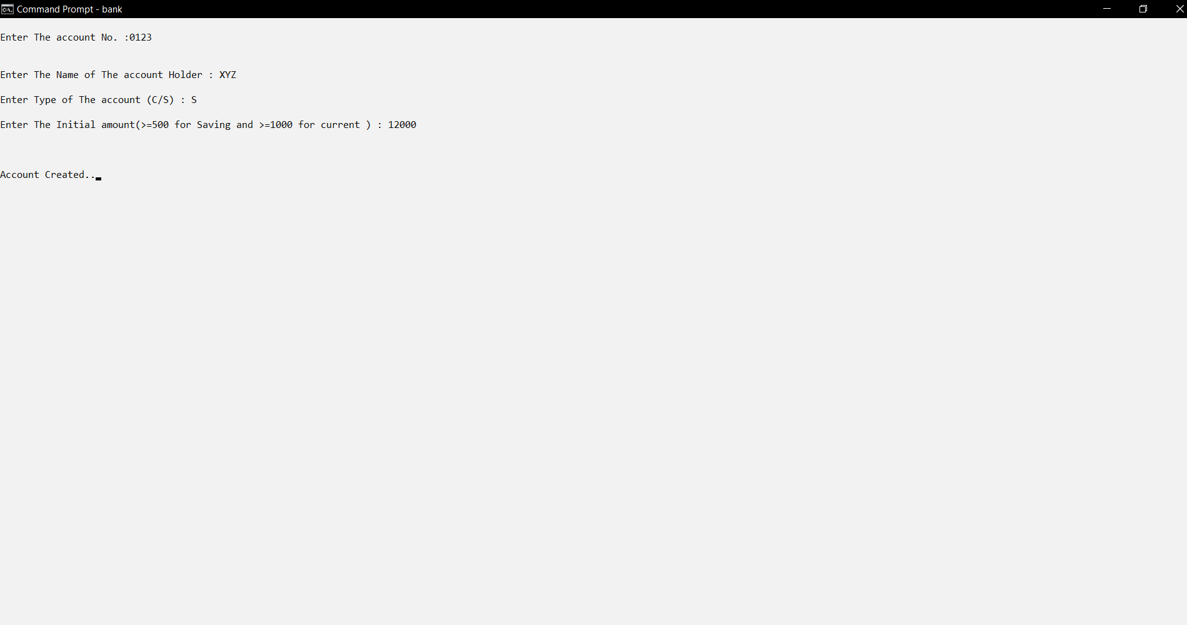

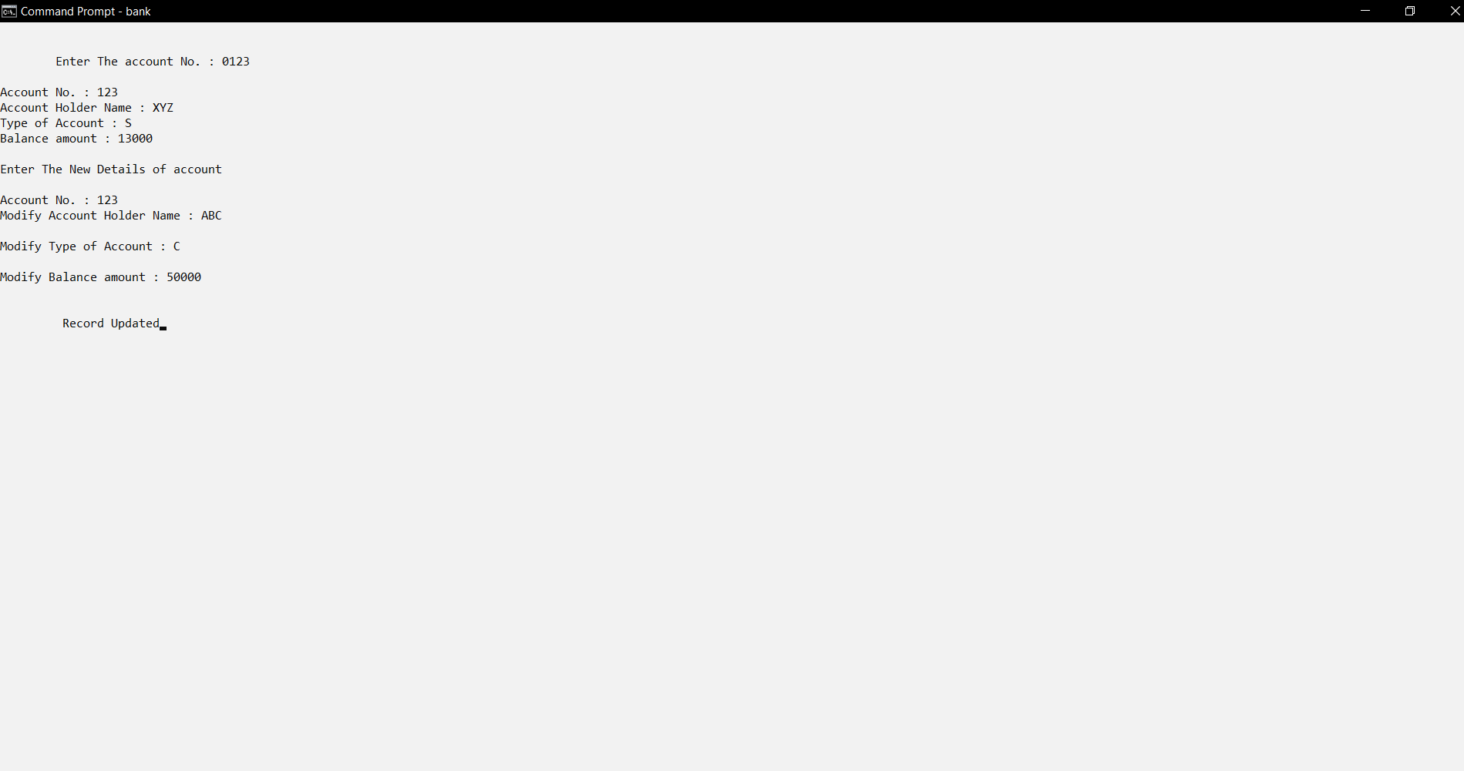

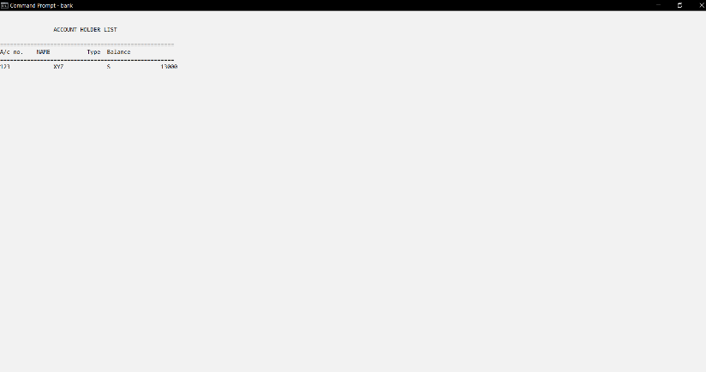

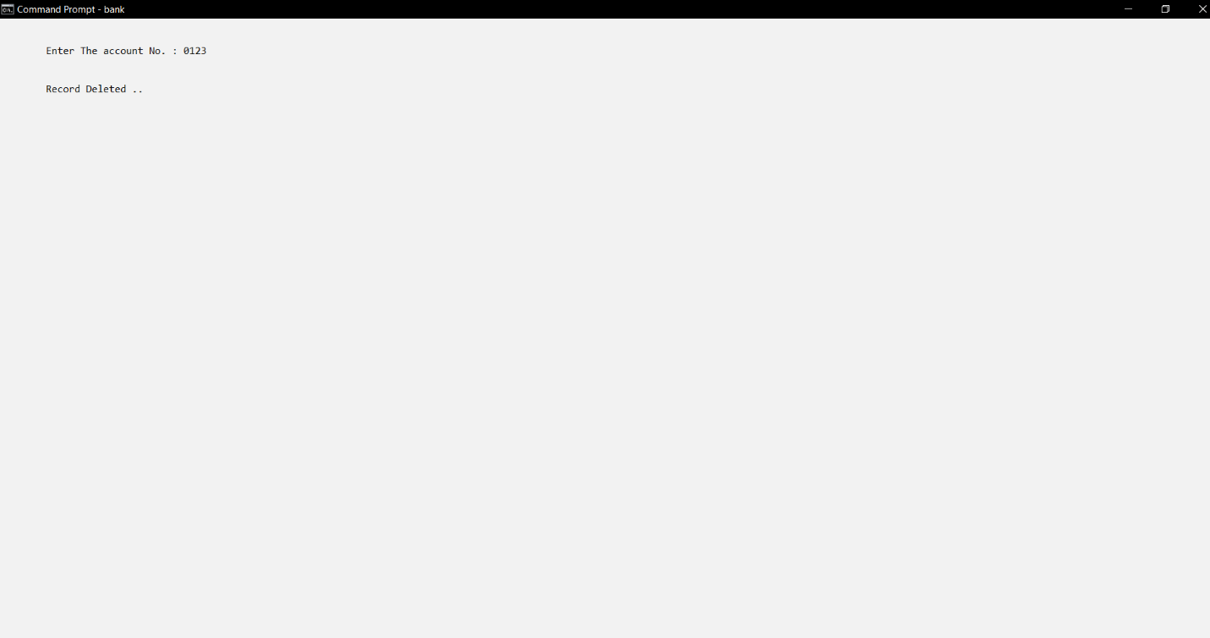

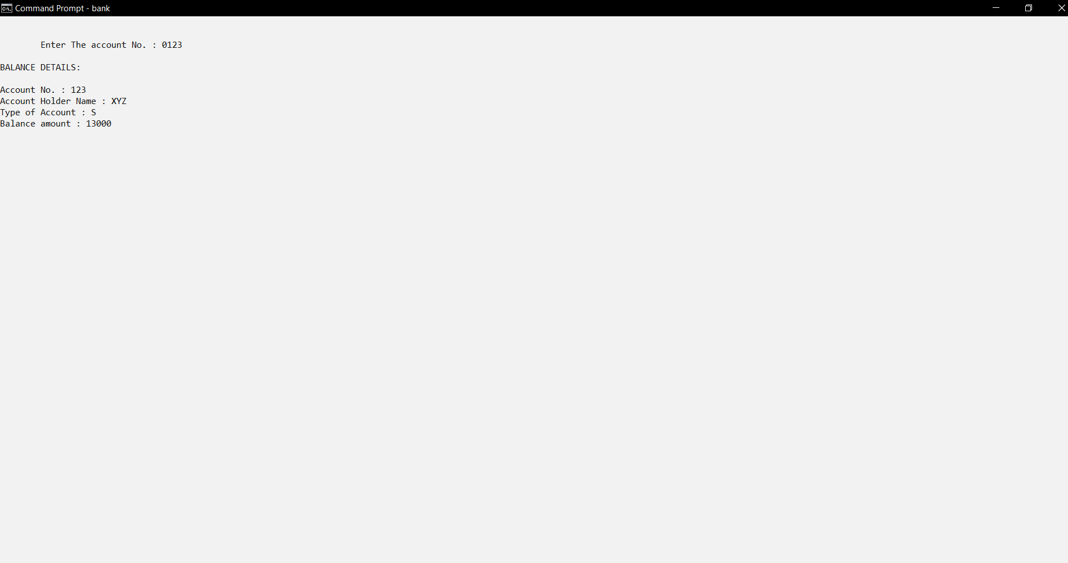

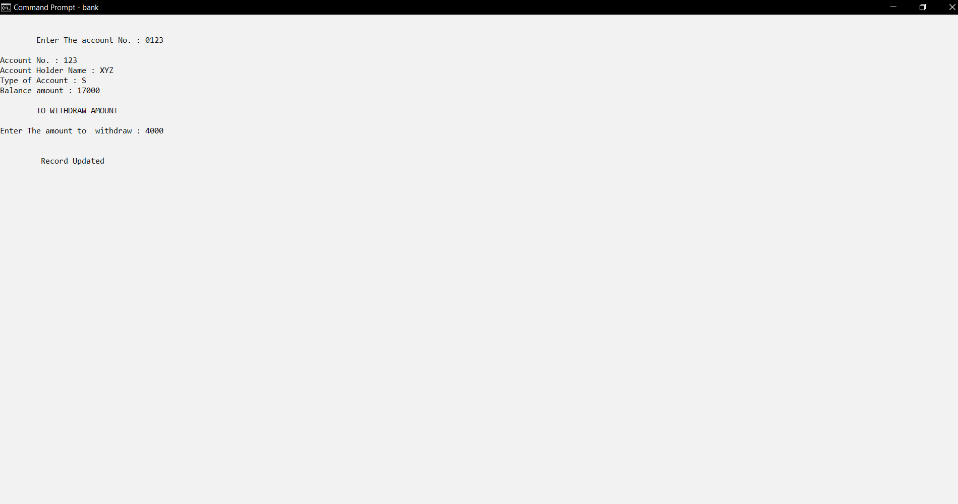

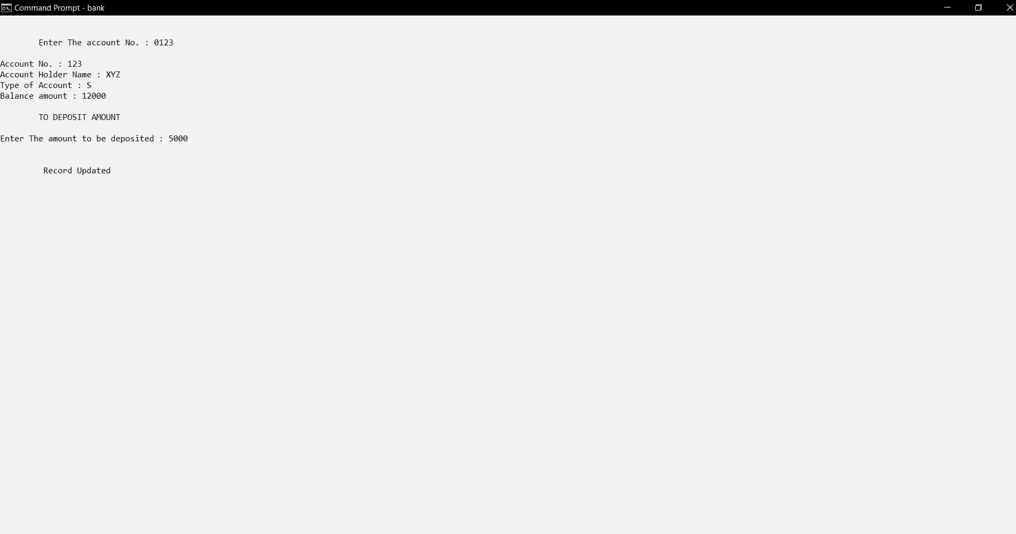

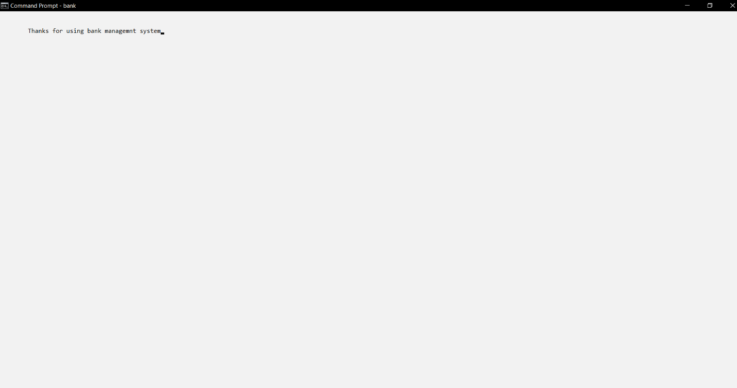

1. **Actual resources used**
   1. Visual Studios for coding
   2. MingW G++ compiler
   3. Google for Reference
2. **Skills developed**

We developed programming skills

We developed searching skills

We developed out team work skills

1. **Application of Microproject**

* Creating the bank account for the customer.
* Deposit amount for the customer.
* Withdraw amount for the customer.
* Balance Enquiry by the customer.
* Show account holder's full detail.
* Closing or terminating a bank account.
* Updating the bank account**.**